**Raspberry pi OS**

**What is OS?**

An operating system (OS) is a fundamental software component that serves as the bridge between computer hardware and the applications and users who interact with it. It is the core system software that manages the computer's resources, such as the CPU, memory, storage devices, and peripherals, while also providing a user-friendly interface for human interaction. The primary functions of an OS include task management, memory allocation, file system management, and input/output control. It acts as a control center, ensuring that multiple processes can run concurrently, sharing resources efficiently and securely. The OS abstracts the hardware complexity, enabling software applications to run on a wide range of hardware configurations without needing to be tailored for each specific setup. Whether it's a personal computer, server, smartphone, or embedded device, an OS is essential for the effective operation and management of computing systems. It plays a crucial role in ensuring that users can interact with their devices, run applications, and perform tasks with ease.

**What is Raspberry pi OS?**

Raspberry Pi OS, formerly known as Raspbian, is an open-source operating system designed specifically for the Raspberry Pi single-board computer. The Raspberry Pi is a popular, low-cost, credit-card-sized computer that was created to promote computer science education and enable DIY electronics projects. Raspberry Pi OS is the recommended operating system for these devices, and it is optimized to provide a user-friendly computing experience on the Raspberry Pi hardware.

Raspberry Pi OS is built on the Debi an Linux distribution, and it benefits from the extensive software ecosystem and support of the Debi an community. It is available in different versions, with the most common being the "Raspberry Pi OS with Desktop" and the "Raspberry Pi OS Lite." The desktop version comes with a graphical user interface and various pre-installed applications, making it suitable for general-purpose computing tasks, while the lite version is a minimal, headless OS intended for more specialized applications.

The OS includes a wide range of software tools and programming languages, making it an excellent platform for educational purposes, hobbyist projects, and even small-scale server applications. It also provides access to the Raspberry Pi's GPIO (General-Purpose Input/Output) pins, allowing users to interact with external hardware and sensors. This capability makes Raspberry Pi OS particularly popular among tinkerers, makers, and those interested in learning about embedded systems and IOT (Internet of Things) development.

Raspberry Pi OS is continually updated and maintained by the Raspberry Pi Foundation, ensuring ongoing support and improvements for the Raspberry Pi community. It offers an accessible and versatile environment for both beginners and experienced users to explore computing, programming, and electronics on this versatile and affordable platform.

**How to Install Operating System to Raspberry pi:**

To use your Raspberry Pi, you’ll need an operating system. By default, Raspberry Pi check for an operating system on any SD card inserted in the SD card slot.

Depending on your Raspberry Pi model, you can also boot an operating system from other storage devices, including USB drives, storage connected via a HAT, and network storage.

To install an operating system on a storage device for your Raspberry Pi, you’ll need:

A computer you can use to image the storage device into a boot device

A way to plug your storage device into that computer

Most Raspberry Pi users choose micro SD cards as their boot device.

We recommend installing an operating system using Raspberry Pi Imager.

Raspberry Pi Imager is a tool that helps you download and write images on mac OS, Windows, and Linux. Imager includes many popular operating system images for Raspberry Pi. Imager also supports loading images downloaded directly from Raspberry Pi or third-party vendors such as Ubuntu. You can use Imager to preconfigure credentials and remote access settings for your Raspberry Pi.

**Methods of Installing Raspberry pi OS:**

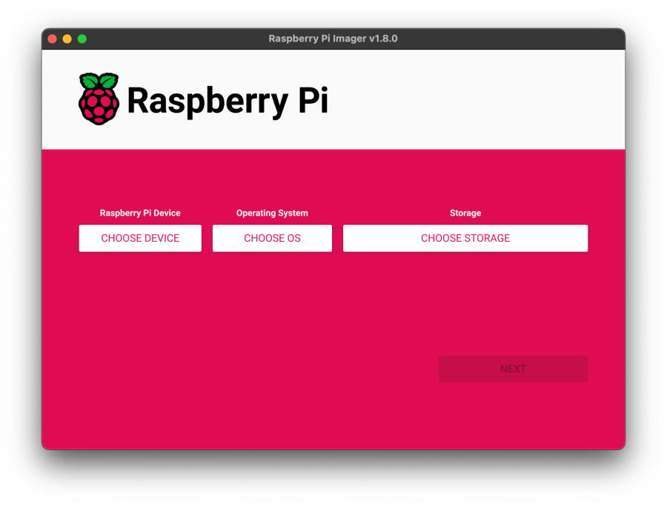**Install using Imager:**

You can install Imager in the following ways:

* Download the latest version from raspberrypi.com/software and run the installer.
* Install it from a terminal using your package manager, e.g. sudo apt install rpi-imager.

Once you’ve installed Imager, launch the application by clicking the Raspberry Pi Imager icon or running rpi-imager.

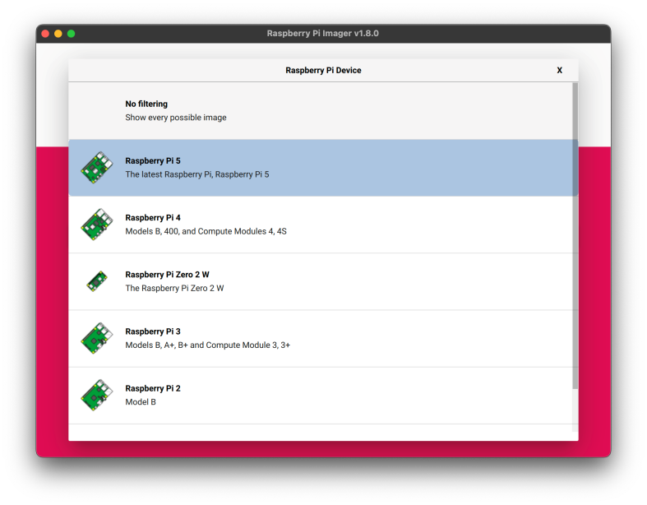Click Choose device and select your Raspberry Pi model from the list.

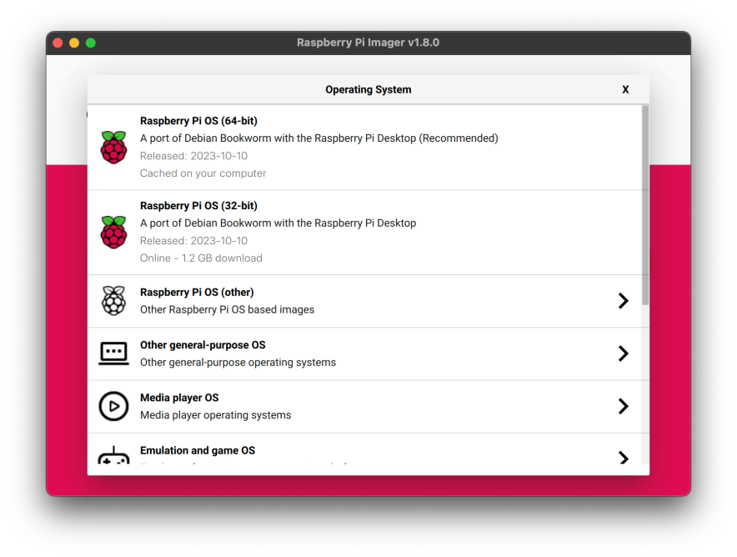

Next, click Choose OS and select an operating system to install. Imager always shows the recommended version of Raspberry Pi OS for your model at the top of the list.

Connect your preferred storage device to your computer. For example, plug a micro SD card in using an external or built-in SD card reader. Then, click Choose storage and select your storage device.

**WARNING**

| If you have more than one storage device connected to your computer, be sure to choose the correct device! You can often identify storage devices by size. If you’re unsure, disconnect other devices until you’ve identified the device you want to image. |
| --- |

Next, click Write.

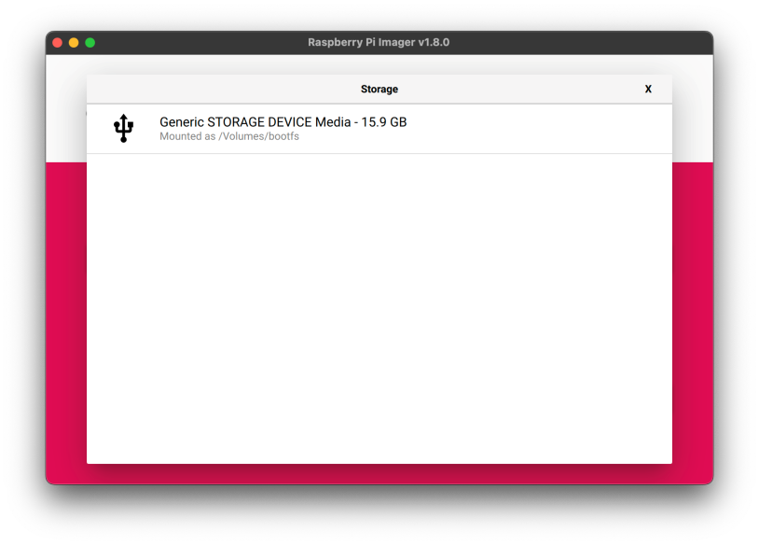

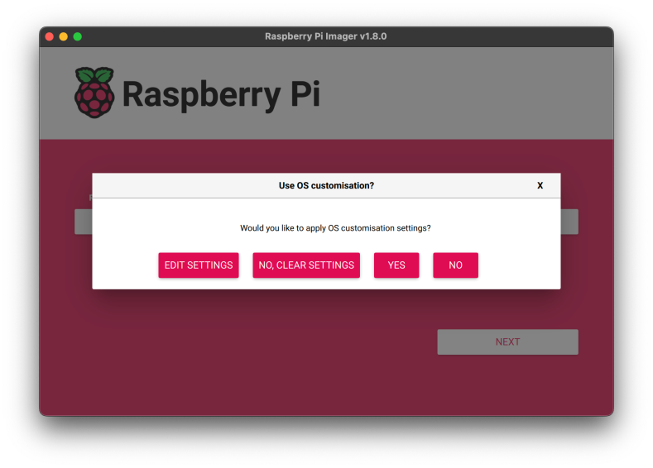

**OS customization**

The OS customization menu lets you set up your Raspberry Pi before first boot. You can preconfigure:

* A username and password
* Wi-Fi credentials
* The device hostname
* The time zone
* Your keyboard layout
* Remote connectivity

When you first open the OS customization menu, you might see a prompt asking for permission to load Wi-Fi credentials from your host computer. If you respond "yes", Imager will prefill Wi-Fi credentials from the network you’re currently connected to. If you respond "no", you can enter Wi-Fi credentials manually.

The hostname option defines the hostname your Raspberry Pi broadcasts to the network using mDNS. When you connect your Raspberry Pi to your network, other devices on the network can communicate with your computer using <hostname>.local or <hostname>.lan.

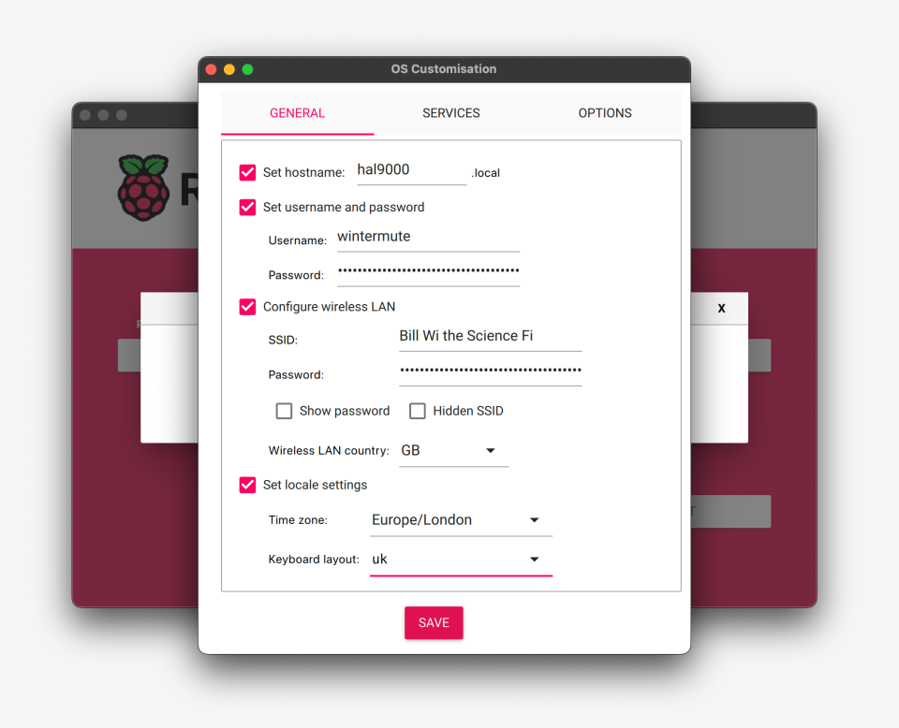The username and password option defines the username and password of the admin user account on your Raspberry Pi.

The wireless LAN option allows you to enter an SSID (name) and password for your wireless network. If your network does not broadcast an SSID publicly, you should enable the "Hidden SSID" setting. By default, Imager uses the country you’re currently in as the "Wireless LAN country". This setting controls the Wi-Fi broadcast frequencies used by your Raspberry Pi. Enter credentials for the wireless LAN option if you plan to run a headless Raspberry Pi

The locale settings option allows you to define the time zone and default keyboard layout for your Pi.

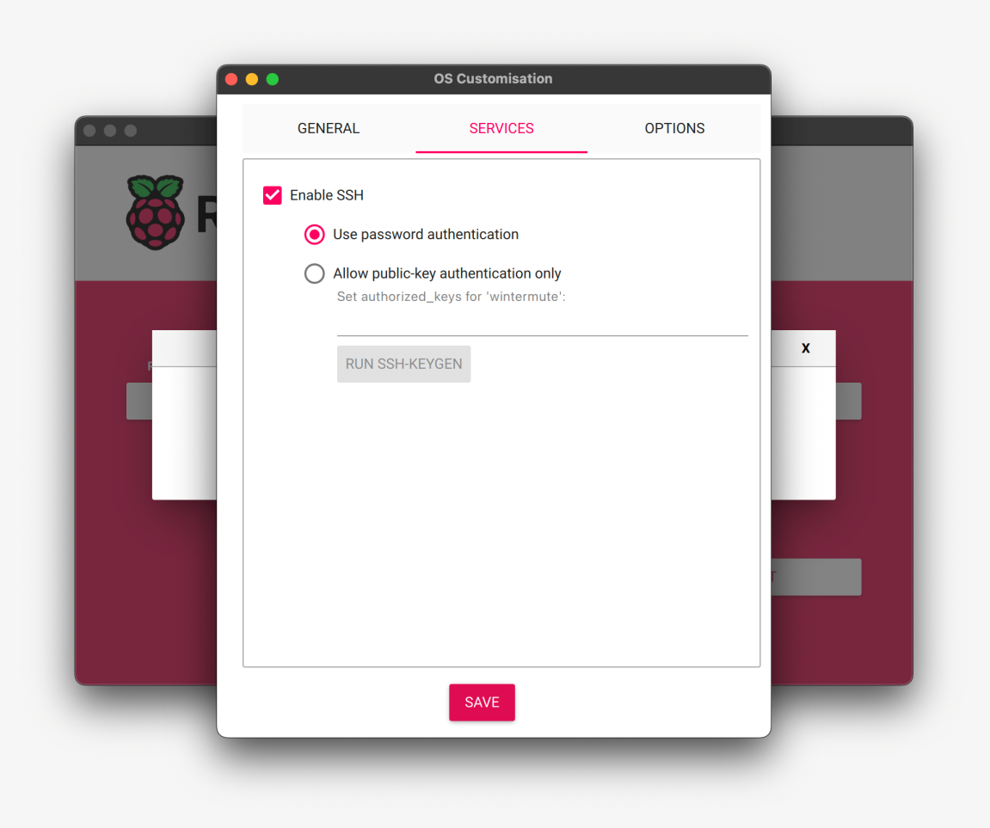The Services tab includes settings to help you connect to your Raspberry Pi remotely.

If you plan to use your Raspberry Pi remotely over your network, check the box next to Enable SSH. You should enable this option if you plan to run a headless Raspberry Pi.

Choose the password authentication option to SSH into your Raspberry Pi over the network using the username and password you provided in the general tab of OS customization.

Choose Allow public-key authentication only to preconfigure your Raspberry Pi for password less public-key SSH authentication using a private key from the computer you’re currently using. If already have an RSA key in your SSH configuration, Imager uses that public key. If you don’t, you can click Run SSH-key gen to generate a public/private key pair. Imager will use the newly-generated public key.

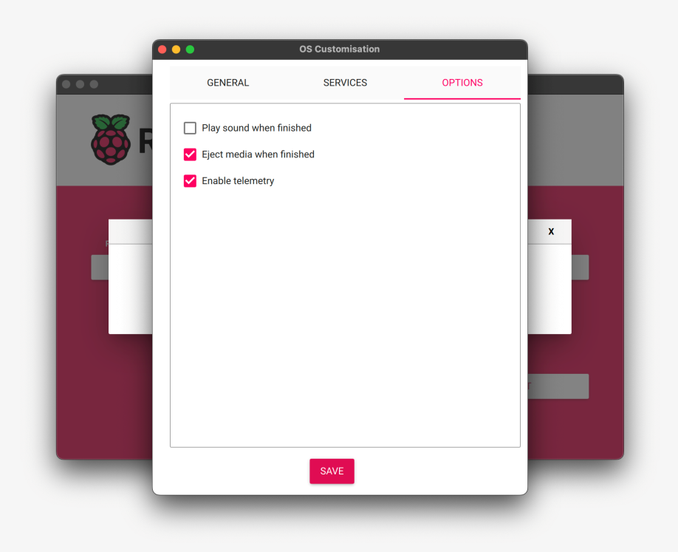OS customization also includes an Options menu that allows you to configure the behavior of Imager during a write. These options allow you to play a noise when Imager finishes verifying an image, to automatically unmounts storage media after verification, and to disable telemetry.

**Write**

When you’ve finished entering OS customization settings, click Save to save your customization.

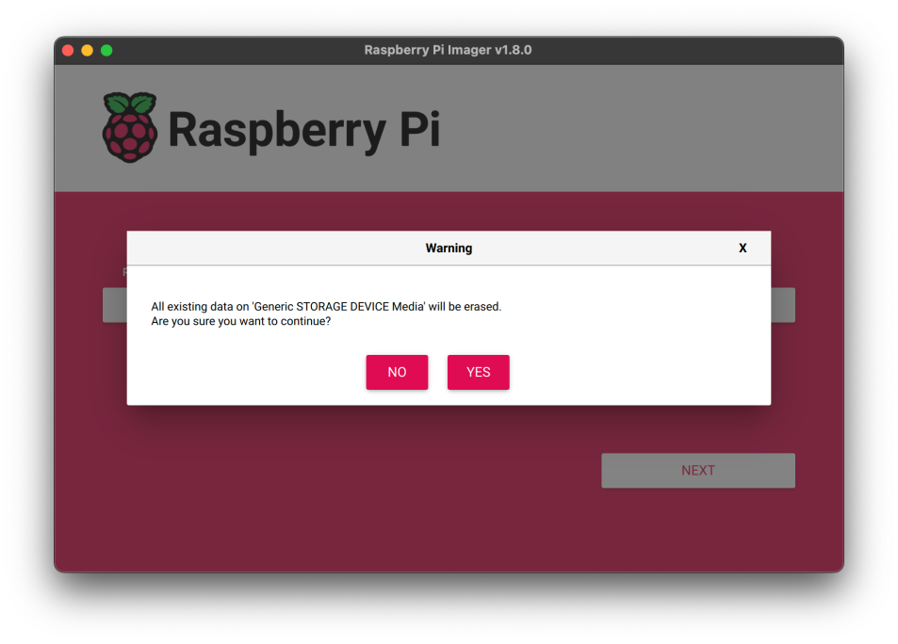Then, click yes to apply OS customization settings when you write the image to the storage device.

Finally, respond Yes to the "Are you sure you want to continue?" popup to begin writing data to the storage device.

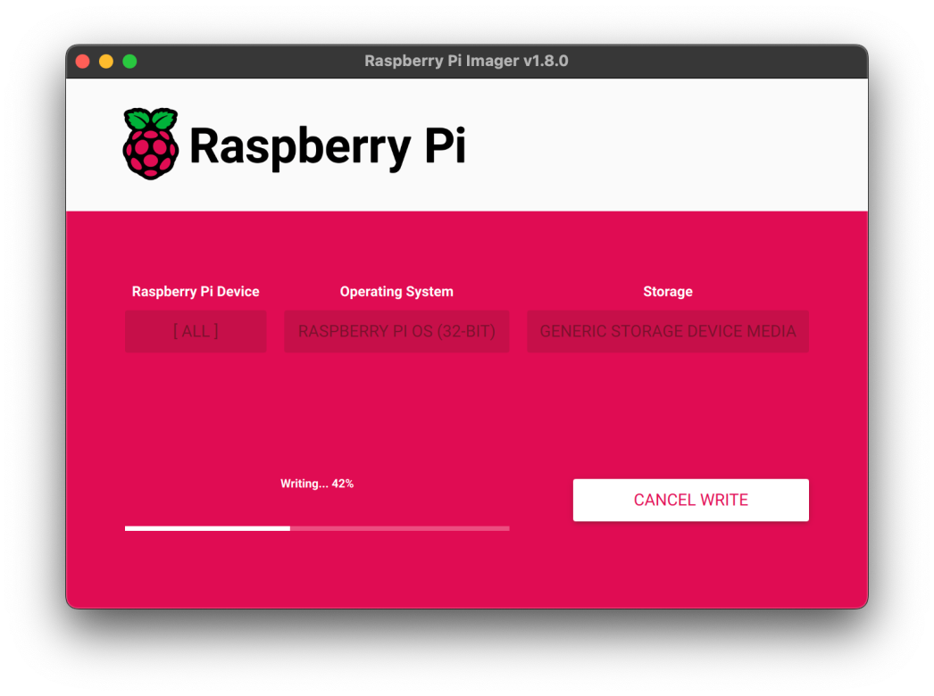If you see an admin prompt asking for permissions to read and write to your storage medium, it’s safe to proceed.

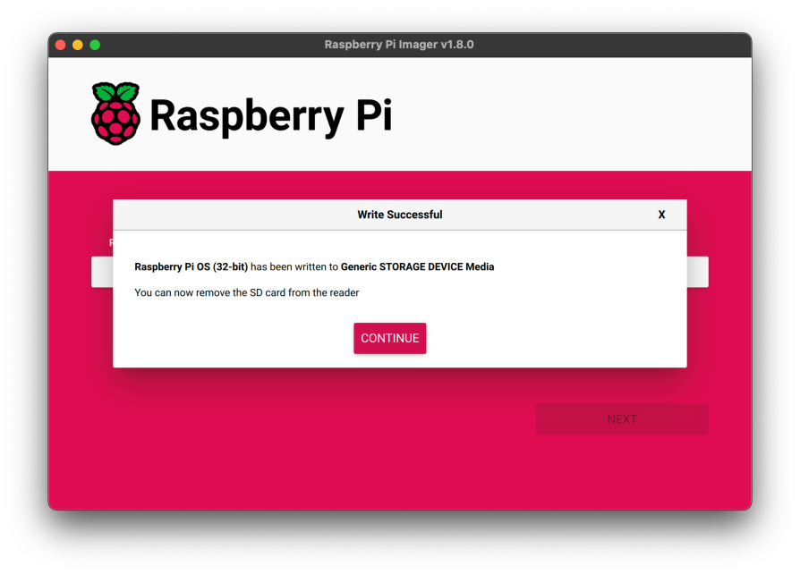

When you see the "Write Successful" popup, your image has been completely written and verified. You’re now ready to boot a Raspberry Pi from the storage device!

**Install over the network:**

Network Install enables a Raspberry Pi to install an operating system on a storage device using a version of Raspberry Pi Imager downloaded over the network. With Network Install, you can get an operating system installed on your Raspberry Pi with no separate SD card reader and no computer other than your Raspberry Pi. You can run Network Install on any compatible storage device, including SD cards and USB storage.

Network Install only runs on Raspberry Pi 4, 400. If your Raspberry Pi runs an older boot loader, you may need to update the boot loader to use Network Install.

**Network Install requires the following:**

A compatible Raspberry Pi model running firmware that supports Network Install

* A monitor
* A keyboard
* A wired internet connection

To launch Network Install, power on your Raspberry Pi while pressing and holding the SHIFT key in the following configuration:

* No bootable storage device
* Attached keyboard
* Attached compatible storage device, such as an SD card or USB storage

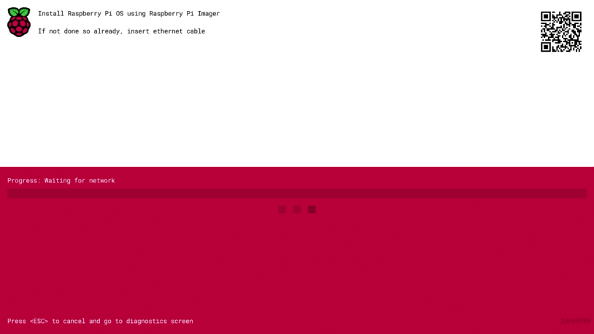

If you haven’t already connected your Raspberry Pi to the internet, connect it with an Ethernet cable.

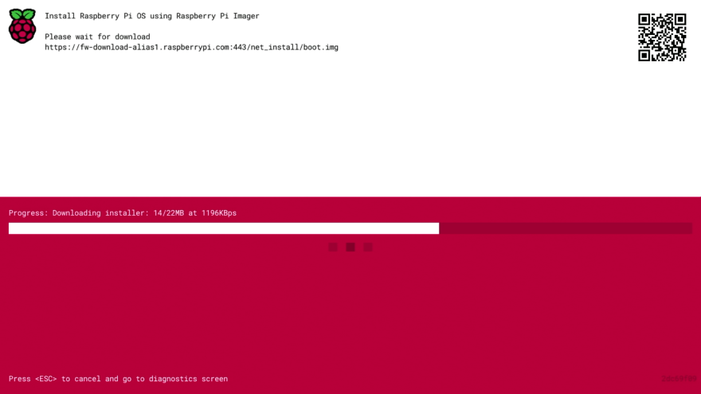

Once you’re connected to the internet, your Raspberry Pi will download Raspberry Pi installer. If the download fails, you can repeat the process to try again.

Once you finish downloading Raspberry Pi Installer, your Raspberry Pi will automatically start Raspberry Pi Imager. For more information about running Raspberry Pi Imager, see install an operating system.

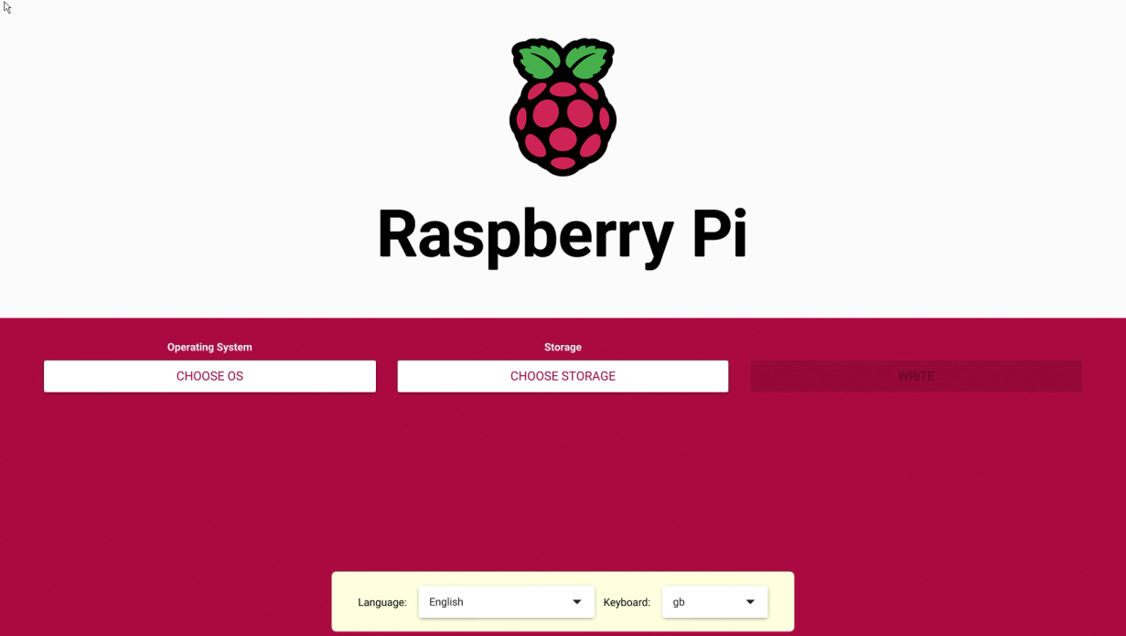

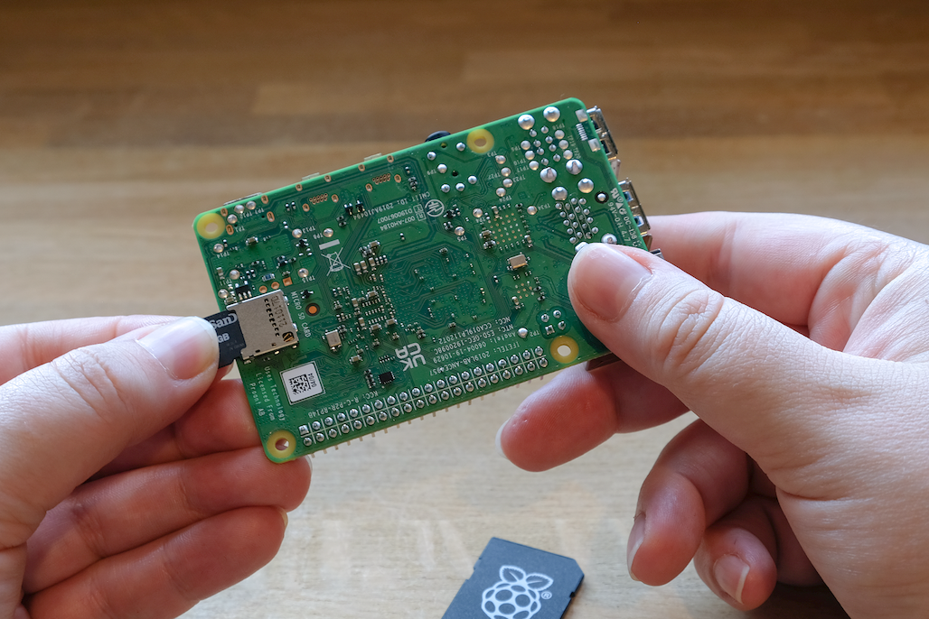**Set up your Raspberry Pi**

After installing an operating system image, connect your storage device to your Raspberry Pi.

First, unplug your Raspberry Pi’s power supply to ensure that the Raspberry Pi is powered down while you connect peripherals. If you installed the operating system on a micro SD card, you can plug it into your Raspberry Pi’s card slot now. If you installed the operating system on any other storage device, you can connect it to your Raspberry Pi now.

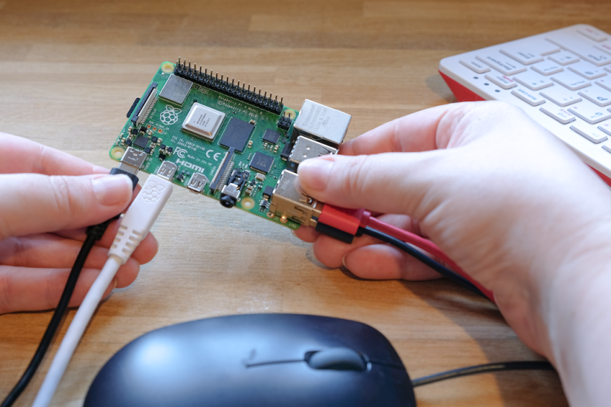

Then, plug in any other peripherals, such as your mouse, keyboard, and monitor.

Finally, connect the power supply to your Raspberry Pi. You should see the status LED light up when your Pi powers on. If your Pi is connected to a display, you should see the boot screen within minutes.

**Configuration on first boot**

If you used OS customization in Imager to preconfigure your Raspberry Pi, congratulations! Your device is ready to use. Proceed to next steps to learn how you can put your Raspberry Pi to good use.

If your Raspberry Pi does not boot within 5 minutes, check the status LED. If it’s flashing, see the LED warning flash codes for more information. If your Pi refuses to boot, try the following mitigation steps:

If you used a boot device other than an SD card, try booting from an SD card Re-image your SD card; be sure to complete the entire verify step in Imager Update the boot loader on your Raspberry Pi, then re-image your SD card.